-------------------------------------------------------------------------------------------------------------------------------NAME: ARCHANA DEVI.P
REG NO: 192521192
COURSE: SOFTWARE TESTING
CODE: CSA0923
LAB PROGRAMS
16. JUnit Testing to Check Whether Two Strings Are Anagrams
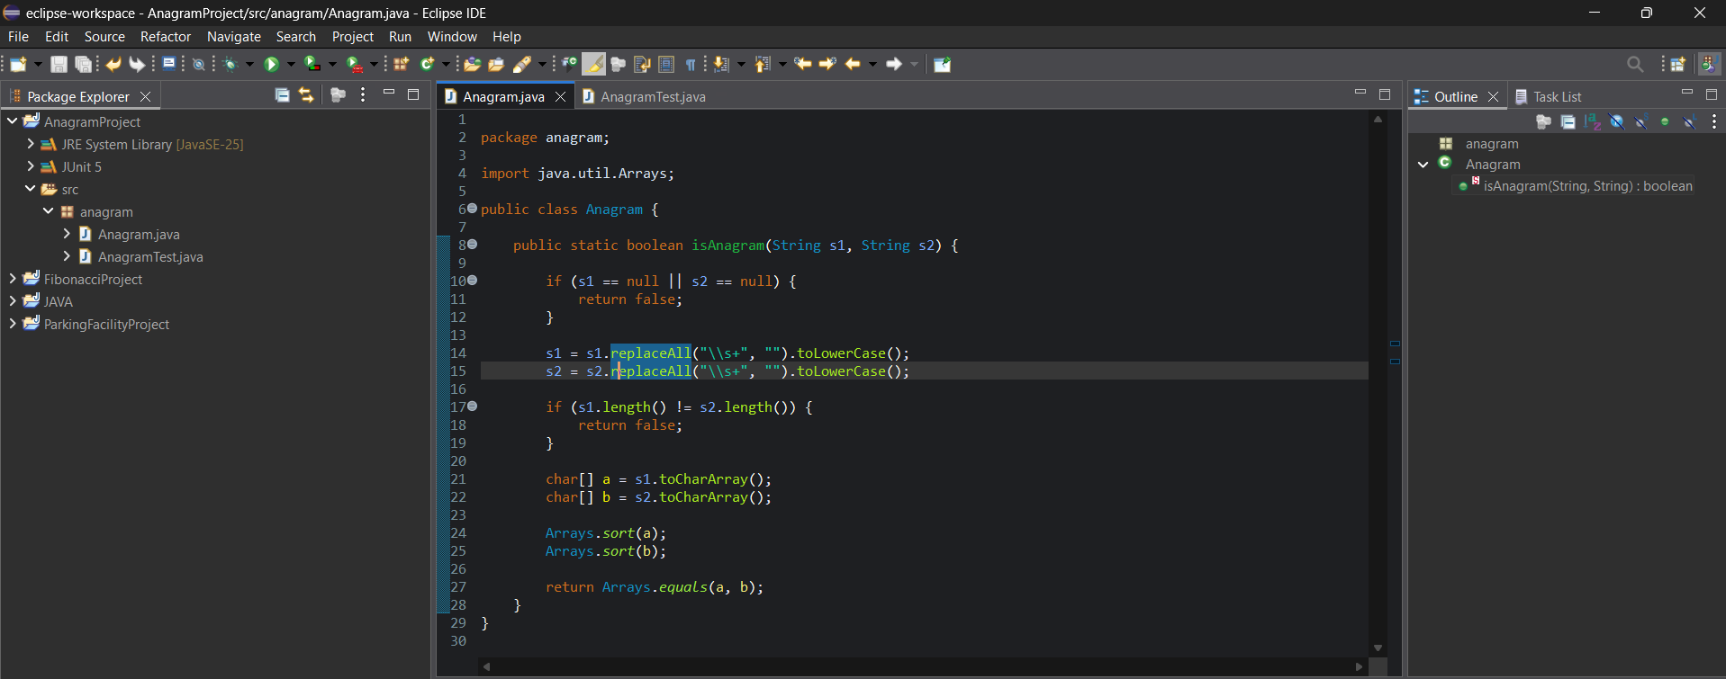

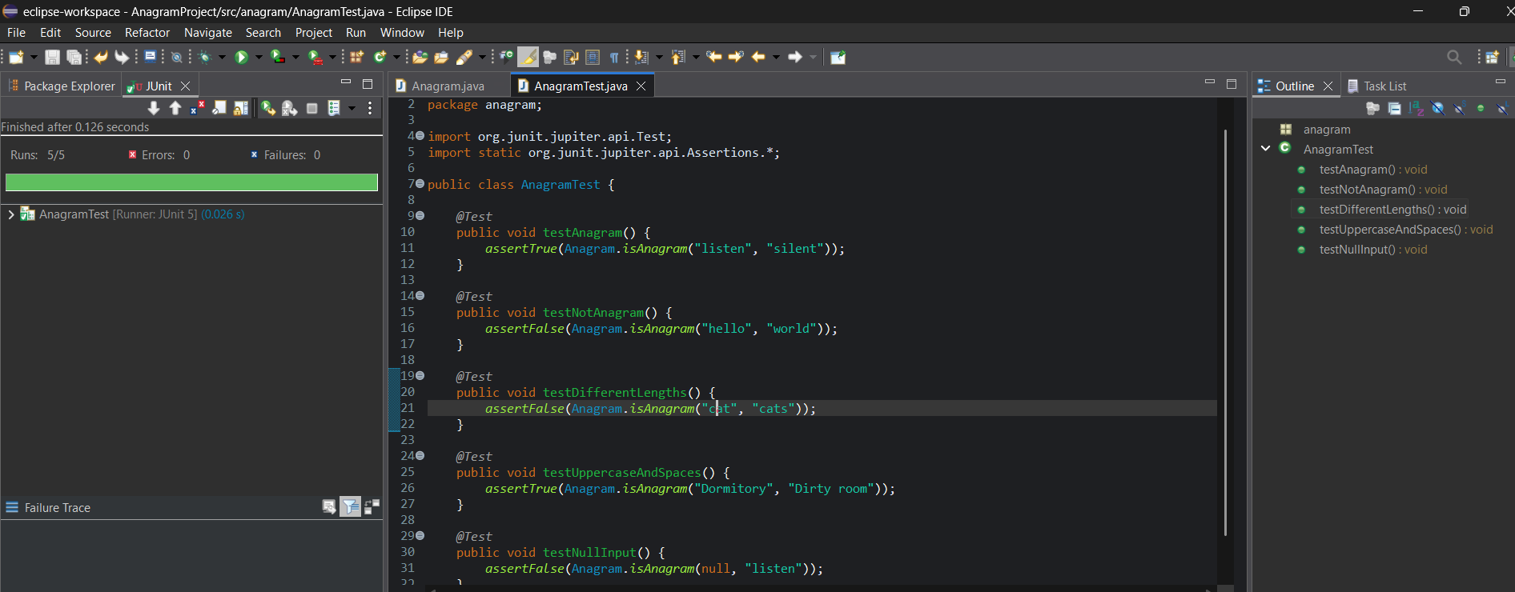
White-box testing
White-box testing examines the internal logic and execution paths of a program.
For the anagram program, the important paths are:
- Null input → returns false.
- Different string lengths → returns false.
- Same letters in different orders → returns true.
- Different letters → returns false.
The test cases exercise these branches, including the two early-return conditions.

Conclusion
JUnit helps automate the testing of Java methods. By using assertion methods and testing different execution paths, we can verify that the anagram program behaves correctly for valid and invalid inputs.

